**Assignment 4 – Packet Tracer**

|  |
| --- |
| * This is an individual assignment, and is worth 20 points. * The due date and time is 11:59 PM, Sep 28. * Use the outcome file to submit your work. * Submit the final outcome after following the instructions. Change the file name following the naming convention: homework, underscore, last name, first initial, and extension (e.g., Assignment4_ImG.pkt). * Copying and submitting someone else’s work is strictly prohibited. When caught, the students (giver and receiver) will receive zero on this assignment and also a 20 points penalty. |

**Task 1**. Complete all the Parts in the following file: *2.1.1.5 Packet Tracer - Create a Simple Network Using Packet Tracer.pdf*.

- Ping Laptop from PC and take a screenshot of the outcome.

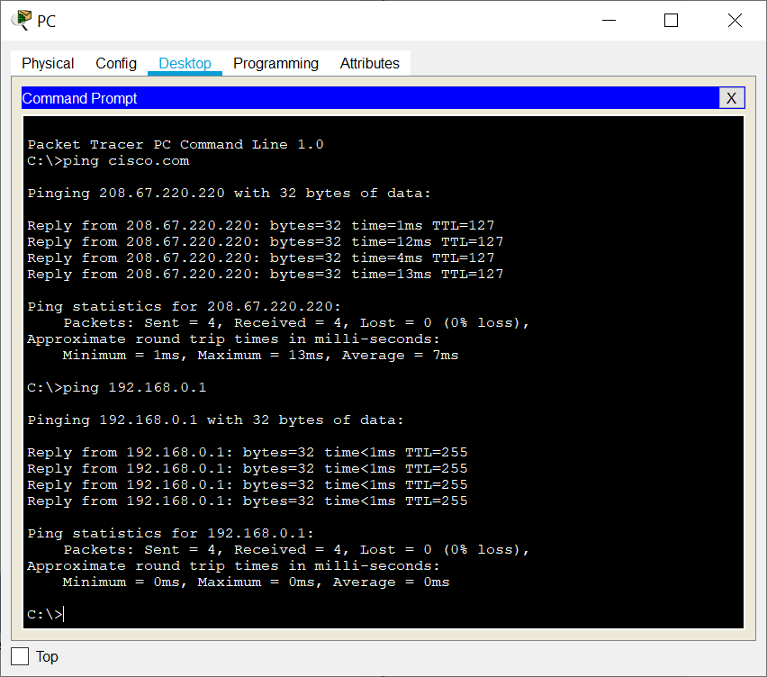

- Ping Cisco.com from Laptop and take a screenshot of the outcome (refer to p. 14).

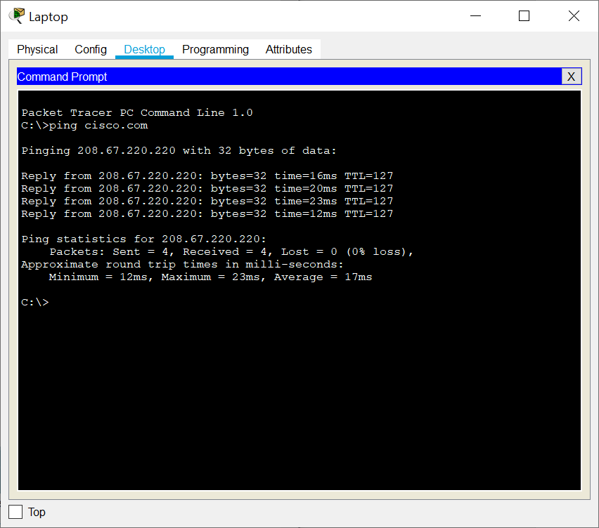

**Task 2.** Change the name of the network devices.

- Ping Laptop from PC and take a screenshot of the outcome.

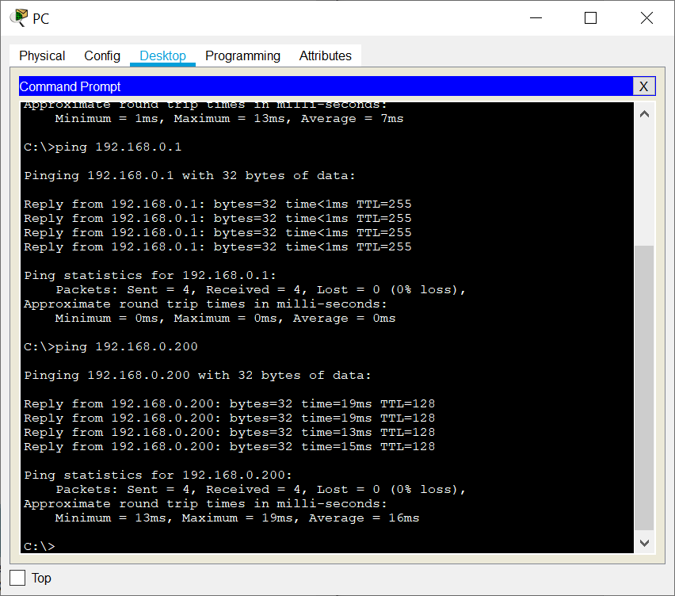

- Ping [your last+first initial].com from PC and take a screenshot of the outcome.

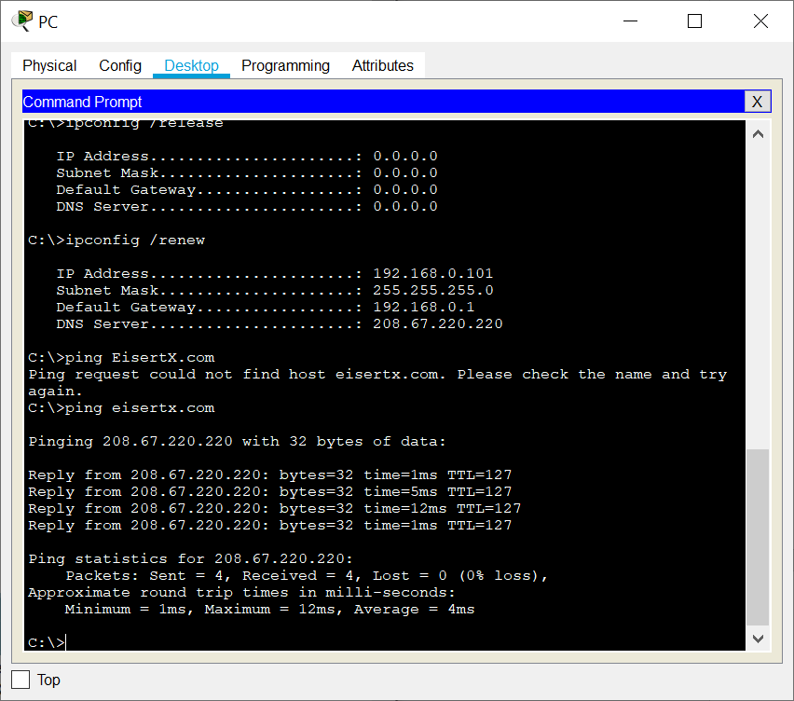

**Task 3**. Complete Parts 1 and 2 (not 3) in the following file: *3.1.1.3 Packet Tracer - Explore Network Functionality Using PDUs.pdf*.

- Take a screenshot of the outcome (like the one on p.4).

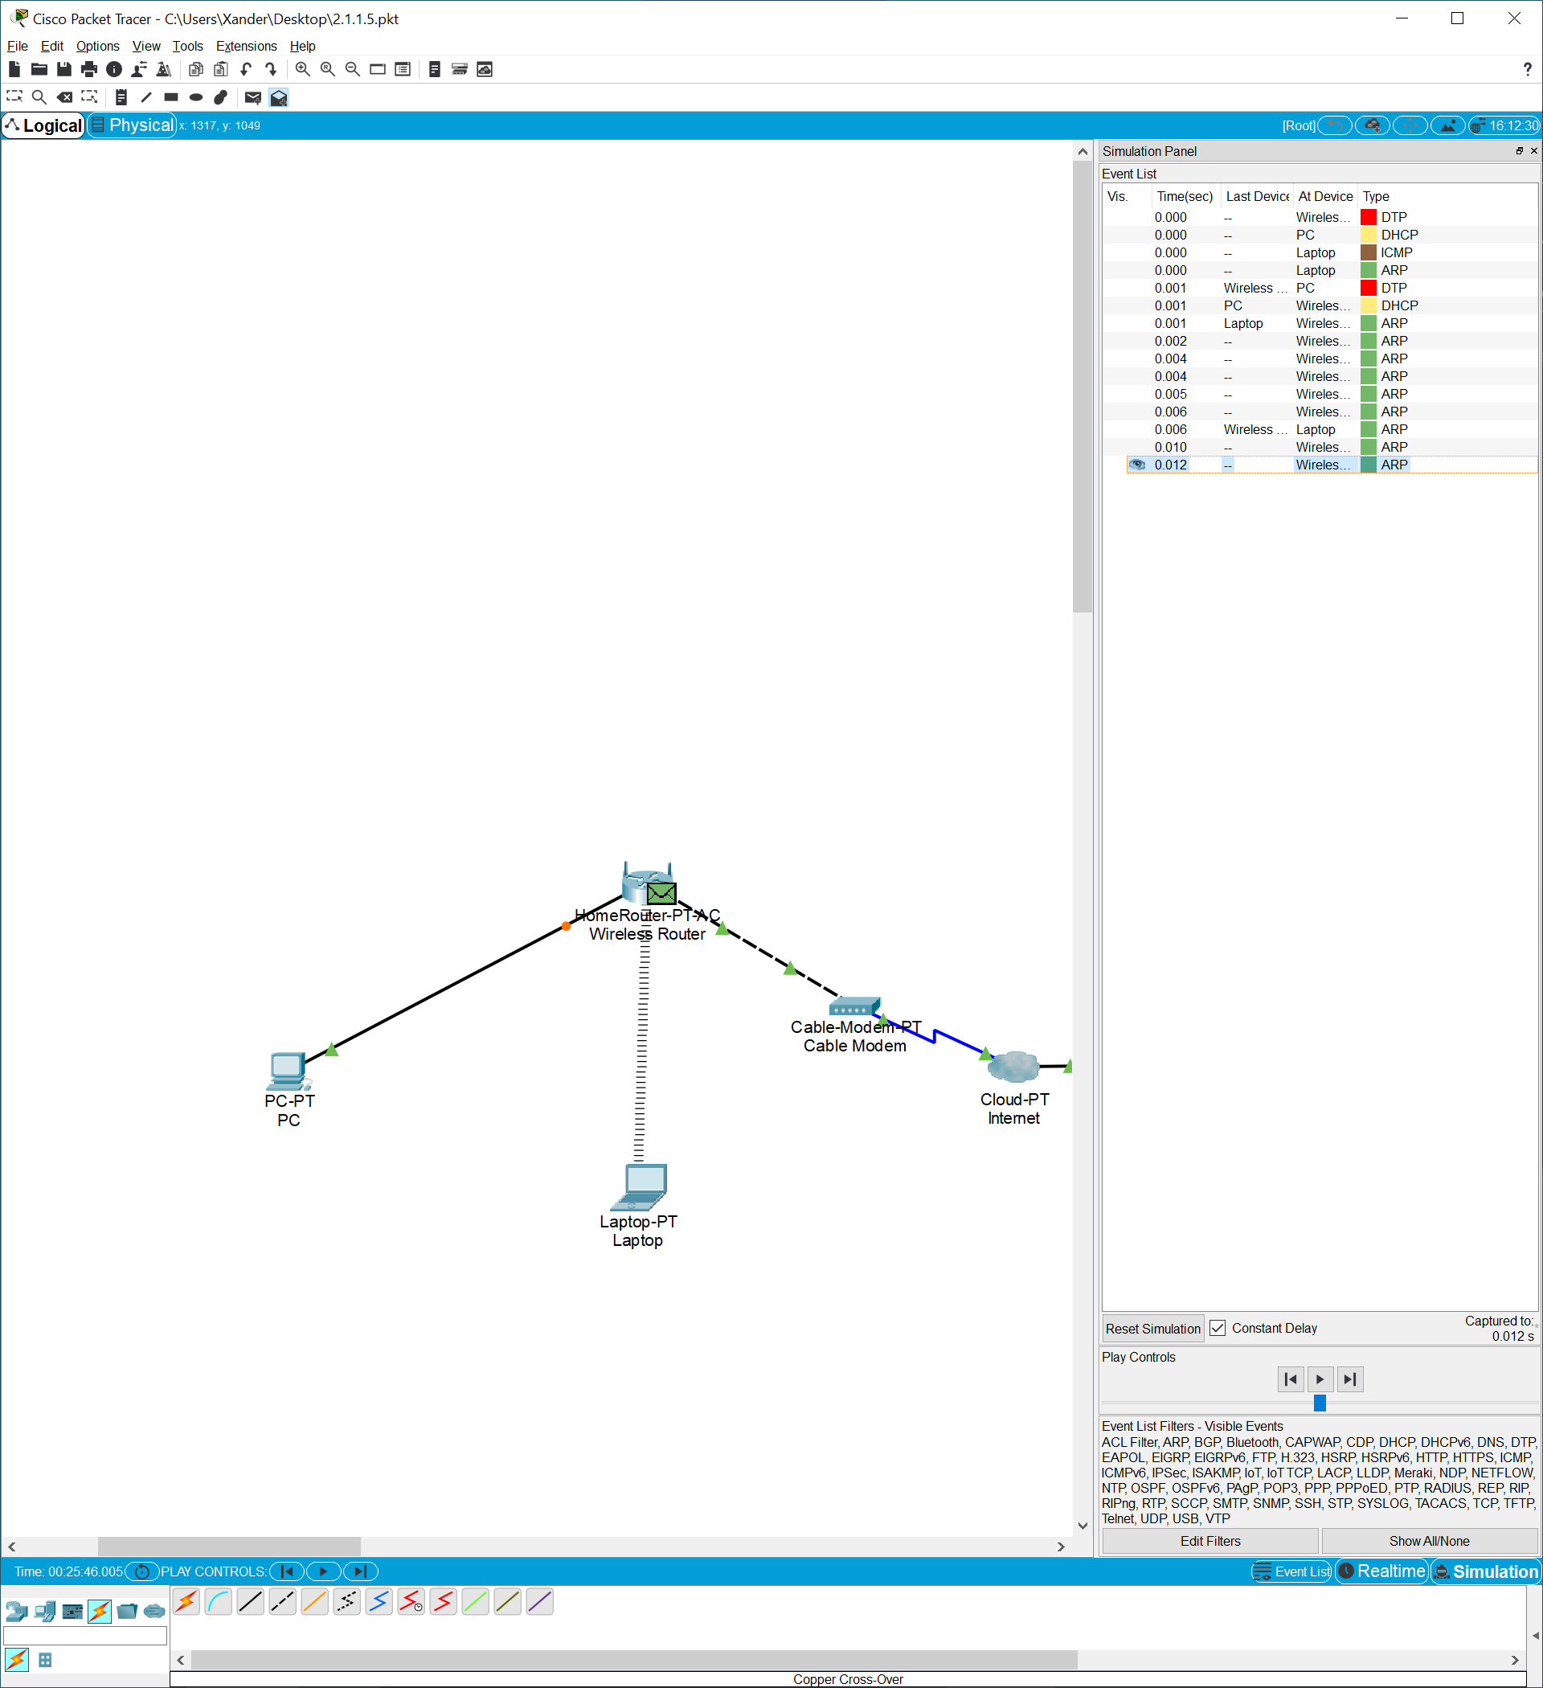

**Task 4**. Submit your *.pkt file.